Practical course

Drug target identification
in
tropical pathogens

07/13 – 07/23/2021

Supervisors:
Sabine Bachmaier
Veronica Ober
Qingping Wu



Table of Contents

In vivo studies on T. brucei PKA – cellular and molecular characterization of PKAR mutants 4
1) Growth analysis 9
2) Analysis of protein expression 12
3) In vivo PKA reporter assay (VASP assay) 14
4) Cell viability assay (Alamar blue assay) 17
Common protocols 21
Counting trypanosomes with a Neubauer counting chamber 21
Assembly of Western blots 23

In the seminar ‘Drug target identification in tropical pathogens’, we talked a lot about drug target identification approaches in general and also in particular for tropical parasites such as Trypanosoma brucei.
The identification of potential drug targets is, however, only the first step in drug development. Validation of putative drug targets is a crucial part of this process and typically involves cell biological and biochemical methods as well as bioinformatics.
Our practical course will focus on drug target validation using T. brucei PKA as an example.

This script covers the experiments and their analysis of the first week of our practical course.

General organizational remarks: the practical course will be held in a virtual online format via zoom.
We will explain the theoretical background and all details to the experiments and the data analysis. As an example dataset, you will get results from the Drug Target course 2019 for most of the experiments. Computational data analysis can and should be conducted independently after detailed instructions from our side. If there are questions, you will have the possibility to discuss with the other course participants via zoom and, of course, we will be available as well.

We all have experienced that online meetings/discussions are usually quite exhausting. Hence, there will be a reasonable number of breaks during each practical course day.

In vivo studies on T. brucei PKA – cellular and molecular characterization of PKAR mutants

The well-characterized eukaryotic protein kinase A (PKA) consists of regulatory (PKAR) and catalytic subunits (PKAC). Binding of the second messenger cyclic AMP (cAMP) to PKAR induces a conformational change resulting in the release of an active catalytic subunit from the inhibitor site (IS) of PKAR (Figure 1).

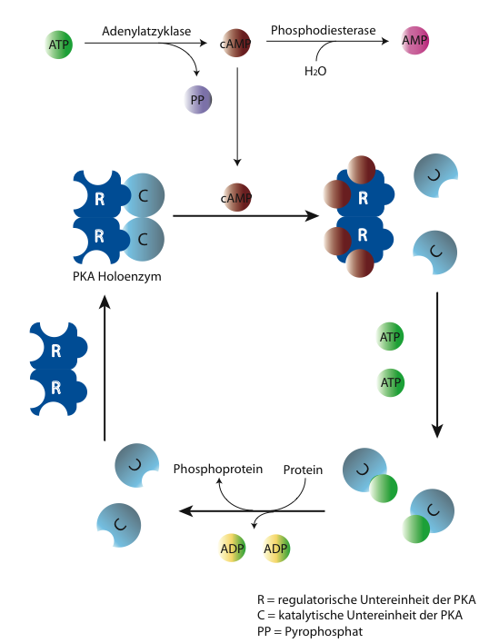

Figure 1: Activation of protein kinase A (PKA) by cyclic AMP (cAMP)

A critical feature of (almost all) cyclic nucleotide-binding proteins (such as PKAR and others) is the presence of a well-conserved cyclic nucleotide-binding (CNB) domain that contains the so-called phosphate-binding cassette (PBC), a short region responsible for interaction with the cyclic phosphate of cAMP (Figure 2). PKAR contains two CNBs, CNB-A and CNB-B. A good video that precisely explains PKA activation by cAMP is found at this link: https://www.youtube.com/watch?v=_PV_ps-mICs.
Surprisingly, despite high overall sequence conservation, the Trypanosoma PKA orthologue does not bind cAMP and hence is not activated by this signaling molecule. By comparing the amino acid sequence of the PBCs of T. brucei PKAR with mammalian PKAR, a few differences at positions critical for cyclic nucleotide binding can be detected (Figure 2, bottom).

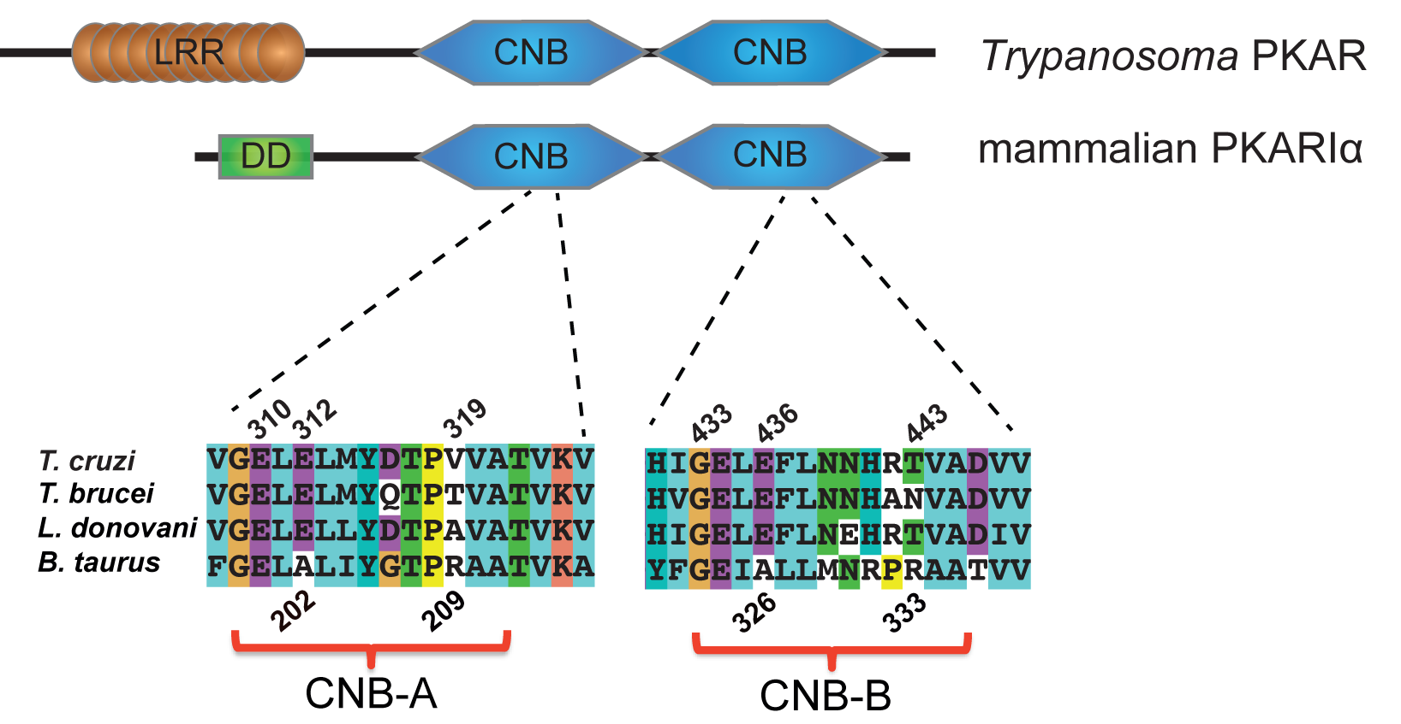
IS
IS
PBC-A
PBC-B
Figure 2: Comparison of kinetoplastid (T. brucei, T. cruzi, L. donovani) PKAR orthologues with mammalian PKAR (Bos taurus PKAR1a). The domain architecture (top) and sequence alignment within the PBC (bottom) are shown. LRR: leucine-rich repeats; DD: dimerization docking domain; IS: inhibitor site; CNB: cyclic nucleotide binding domain; PBC: phosphate binding cassette.

In addition to the affinity loss for cAMP, we have recently identified and further developed several membrane-permeable nucleoside derivatives that bind to and activate trypanosomal PKA (Bachmaier et al., 2019). Importantly, these compounds do not bind to or activate mammalian PKA. The identity of the physiological ligand(s) of the parasite PKAR are, however, unknown and are a major focus of ongoing research.

By site-directed mutagenesis within the PBCs, we have generated a T. brucei PKAR mutant cell line capable of binding cAMP (several residues within both PBCs have been mutated to match the human PKAR sequence, see Figure 3). This trypanosome cell line will further on be called ‘PBC mutant’.

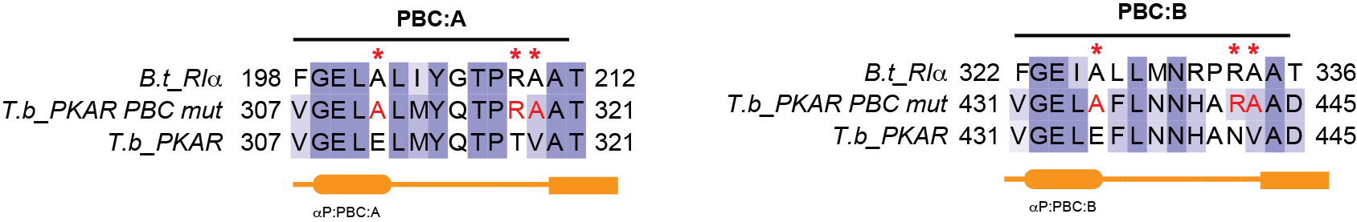
Figure 3: Single point mutations introduced into the Trypanosoma brucei PKAR-PBC mutant.

Moreover, we have generated a cell line that expresses PKAR with a threonine to alanine mutation (T205->A) at amino acid position 205 within the inhibitor site (IS; interaction site with PKAC) of the protein (see Fig. 4). As T205 needs to be phosphorylated to ensure proper inducibility of PKA, a mutation to alanine prevents phosphorylation and hence interferes with PKA activation. This mutant cell line will further on be called ‘T205A mutant’.

...RRTT...

Figure 4: Trypanosoma PKAR domain organization with zoom into the inhibitor site (IS) sequence. The residue threonine 205 (T205, marked in red) is critical for interaction with PKAC and was mutated to alanine in the mutant PKAR-T205A.

The identification of compounds that target the parasite protein but not the host orthologues is a major aspect in drug development. Yet, this is not sufficient for validation of trypanosomal PKA as drug target. Hence, the aim of our in vivo experiments is to characterize the phenotypes of T. brucei PKAR mutants at the cellular and molecular level. As in every scientific experiment, we need to include control cell lines: a wild type cell line, a PKAR knock out cell line and a PKAR add-back cell line (explanation below).

Explanation of T. brucei cell lines:

‘Wild Type‘: expresses wild type T. brucei PKAR (two alleles as trypanosomes are diploid)
‘PKAR knock out’; both alleles of PKAR have been deleted = homozygous knock out
‘PKAR add-back’: a single PKAR allele has been added back into the PKAR knock out cell line
‘PBC mutant’: a single allele of PBC mutant PKAR is expressed in the PKAR knock out cell line
‘T205A mutant: a single allele of T205 mutant PKAR is expressed in the PKAR knock out cell line

You will do the following assays for phenotypic characterization:
- Growth analysis
- Analysis of protein expression
- In vivo PKA reporter assay (VASP assay)
- Cell viability assay (Alamar blue assay)

The results obtained will be entered into the following Excel table (available separately in Excel format on the course webpage):

Table 1: Phenotypic in vivo analysis of T. brucei PKAR mutants
cell line
replicate # |  | 1 | 2 | 3
PDT logarithmic growth
growth to stationary phase | time point
growth to stationary phase | max. density
protein expression  (intensity counts normalized to PFR & WT set to 100%) | PKAR
 | PKAC1
VASP assay | % basal VASP phosphorylation
VASP assay | fold induction  upon Toyo treatment
Alamar blue assay Toyo EC₅₀

At the end, we will combine and compare the results of all cell lines and interpret our observations.

Growth analysis

What you will learn from this experiment:
- how do I get from raw cell counts (e.g. using a counting chamber, see pages 21/22 how to use it) to a cumulative growth curve?
- how to use Excel and GraphPad Prism for growth curve generation and visualization
- is PKA required for proper growth and development of T. brucei?

You will analyze the growth behavior of the above mentioned T. brucei cell lines (see page 7) over four days, combine the daily counts to a growth curve and determine the population doubling time (PDT), i.e. the time the culture needs to double (maybe this procedure is known to some of you from the Genetics 2 practical course).
In the mammalian bloodstream, T. brucei proliferates as so-called long slender bloodstream form. This is the life cycle stage, which we are cultivating in the practical course, as long as the cells are in the logarithmic growth phase (density below 1.2x10⁶ cells/ml). When the cell density further increases, the parasites differentiate into the short stumpy (-like) stage accompanied by growth arrest and morphological changes. In order to analyze whether PKAR plays a role in this differentiation step, the cell lines were cultivated over four days without dilution and counted daily until they reached the stationary growth phase. Differences in maximal density and/or the duration to reach stationary growth may be associated with a differentiation phenotype.
We will investigate whether PKAR plays a role for proper growth of trypanosomes in the log and the stat growth phase.
In order to see how reproducible the results are, all cell lines were cultivated as three parallel cultures.

Analysis: the Excel workbook ‘cell count’ (see screenshot in Figure 5) provides you with the raw counts (Fig. 5, green column) determined for each of the five cell lines on each of the four days. This sheet automatically calculates additional values such as the current cell density (Fig. 5, orange column) or the inoculation volume (Fig. 5, yellow column) of your culture for the next day. At the bottom you can switch between separate Excel sheets that display the cell counts on each of the four days, either for logarithmic growth (log) or stationary growth (stat).

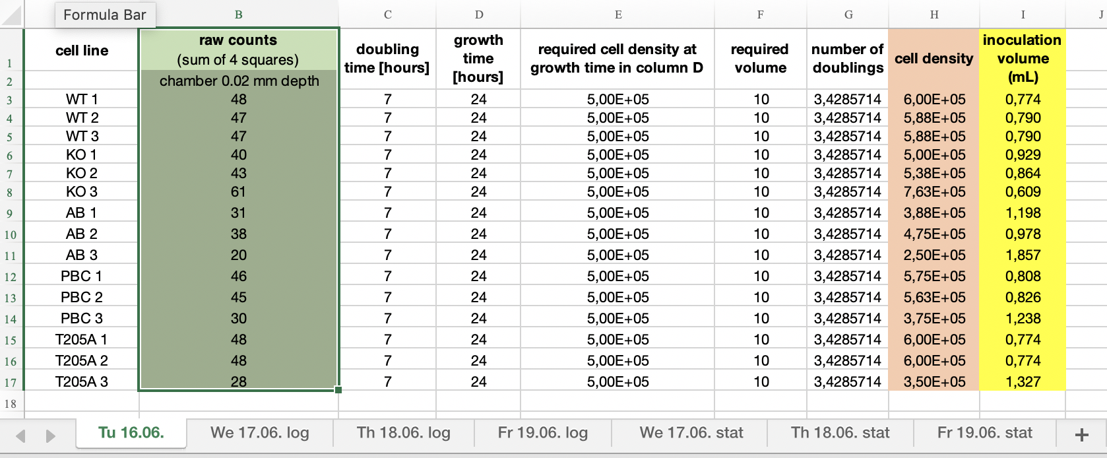
Figure 5: Screenshot of Excel workbook ‘cell count’. Columns from left to right show: (A) cell line, (B) raw cell counts in Neubauer counting chamber (green), (C) doubling time (set to 7h), (D) growth time (set to 24h), (E) required density at growth time in (D), (F) required volume (set to 10 ml), (G) number of doublings, (H) current cell density, (I) inoculation volume [ml] (which volume of cell suspension do I have to add in a total volume of 10 ml (F) in order to get the required density (E) at the desired growth time (D)).

You don’t have to enter anything in the Excel workbook ‘cell count’, but you will need to copy the cell densities (orange column) and inoculation volumes (yellow column) and paste them into the Excel workbook ‘growth curve’ (see screenshot in Figure 6).

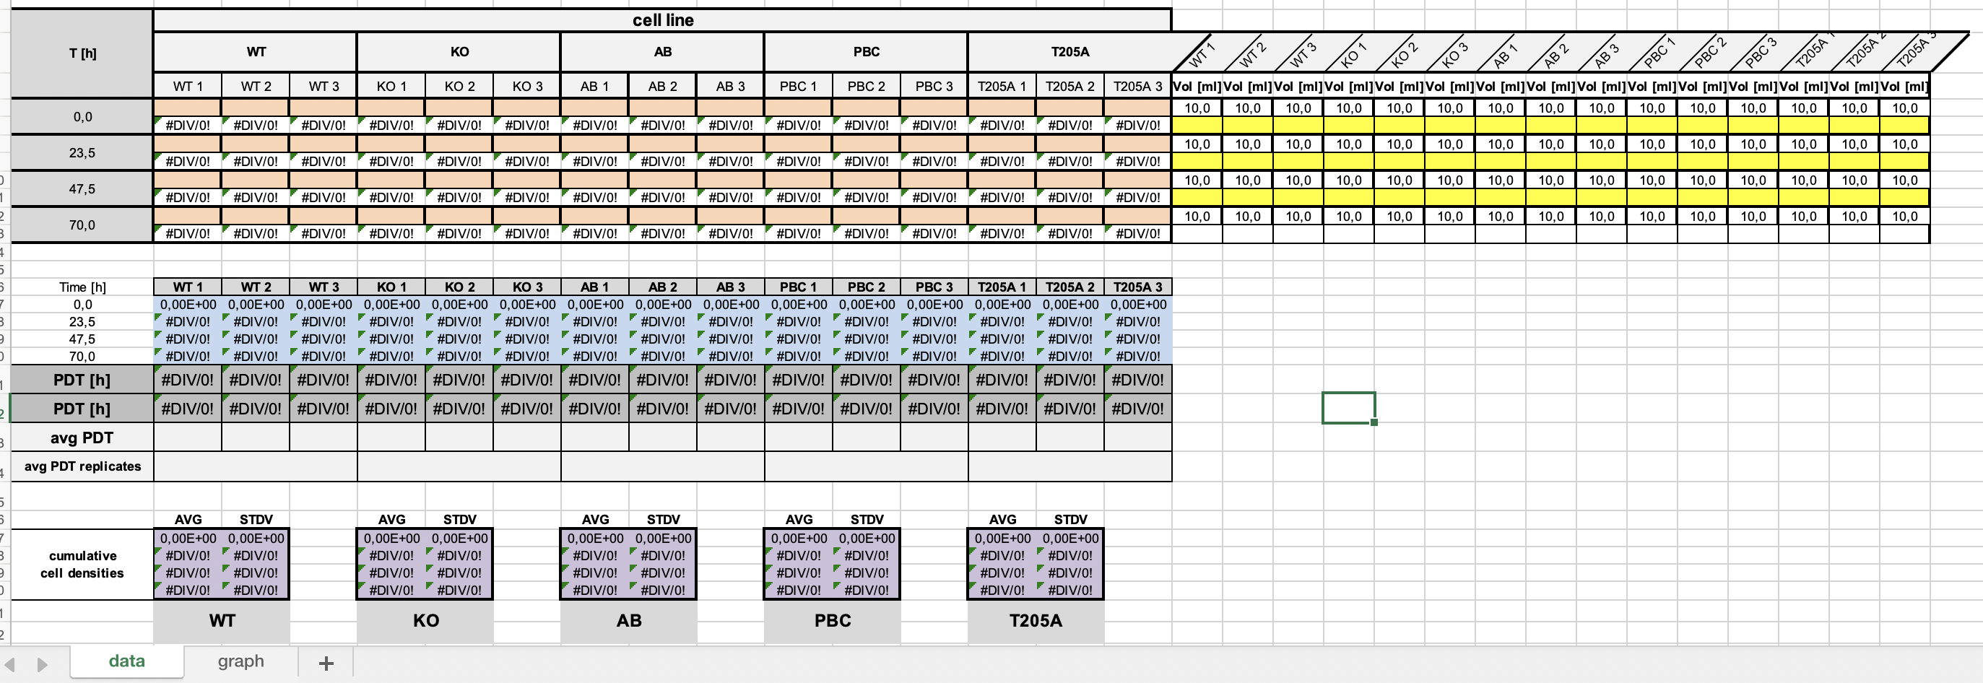
Figure 6: Screenshot of Excel workbook ‘growth curve’. The sheet displays the cell lines, growth time T [h], cell densities (in orange, to be pasted from Excel workbook ‘cell count’), inoculation volume (in yellow, to be pasted from Excel workbook ‘cell count’), population doubling times (PDT) and cumulative densities (blue) of individual cultures as well as average and standard deviations (purple) from the replicate cultures.

The cell densities (Excel sheet ‘cell count’, orange column) need to be pasted into the orange rows of Excel sheet ‘growth curve’ (copy, paste & transpose the values). Also copy and paste the inoculation volumes (‘cell count’, yellow column) to the yellow rows of Excel sheet ‘growth curve’ (copy, paste special & transpose the values). After pasting all the values, the Excel sheet will automatically calculate the cumulative cell densities as well as the PDTs. In addition, the cumulative cell densities will be displayed as graphs in the second sheet of this workbook ‘ (see at the bottom of Fig. 6).

Do this analysis for the log cultures and the stat cultures separately.

Enter required values in Table 1 (Phenotypic in vivo analysis of T. brucei PKAR mutants) and compare the results obtained for the different cell lines

Next, we will continue the analysis using the software GraphPad Prism, which allows quick and easy generation of nice graphs in publication style. In addition, it offers great tools for statistical analysis. You will get a detailed introduction into your 30-day free Prism trial and how to use this software for different types of graphs and statistical analyses.
create growth curves in Prism and export as PDFs for your practical course protocol.

Analysis of protein expression

What you will learn from this experiment:
- theoretical background to protein expression analysis by Western blot
- quantitative analysis of two-color fluorescent Western blots using the software ImageStudioLite
- expression of PKA subunits in wildtype and different mutants of T. brucei

Whole cell lysates of T. brucei cells were generated according to the following protocol for protein expression analysis by Western blot:
- 2x10⁷ cells of each of the three replicate cultures were harvested by centrifugation: 10 min 1400g RT
- the supernatant was poured off into a liquid waste beaker
- the cell pellet was resuspended in 1 ml 1x PBS and transferred to a 1.5 ml tube
- after centrifugation (10 min 1400g RT), the supernatant was removed quantitatively with a pipet
- the cell pellet was resuspended in 60 µl 1x Laemmli sample buffer and incubated 5 min at 95°C, followed by sonication (sheers DNA released from the cells and thereby reduces viscosity = makes gel loading easier)

- run SDS PAGE
  - three Western blot samples were generated from each cell line (= three replicates)
  - three gels were run with the following loading scheme:

lane | 1 | 2 | 3 | 4 | 5 | 6 | 7 | 8 | 9 | 10
load | empty | empty | marker | wild type | PKAR knock out | PKAR add back | PBC mutant | T205A mutant | empty | empty

  - we expect three very similar Western blots (three replicates)
  - 14 µl of sample and 3 µl of the protein marker (NEB Blue Prestained Protein Standard) were loaded
  - gels were run for ~1 hour at 20 mA per gel

- proteins were transferred to a PVDF membrane by Western blotting (see ‘common protocols’, p.23)
- membranes were blocked in 5 ml 5% milk in PBS for 1h at RT (in order to saturate unspecific binding sites for antibodies)
- membranes were incubated with the primary antibodies anti-PKAR (rabbit, 1:250), anti-PKAC1/2 (rabbit, 1:500) and anti-PFR-A/C (mouse; 1:1000; detection of this protein serves as loading control for normalization) in 5 ml 1% milk/0.1% PBST overnight at 4°C on a roller

- membranes were washed 4x 5 min with 5 ml 0.2% PBST
- membranes were incubated 30-60 min at RT (in the dark, as the fluorescently labeled antibodies are light-sensitive) with secondary antibodies (IRDye680 anti-rabbit 1:2500; IRDye800 goat anti-mouse 1:5000) in 5 ml 1% milk/0.1% PBST, 10 µl 10% SDS solution (strongly reduces background!)
- 4x 5 min washes with 5 ml 0.2% PBST, final wash with water
- membranes were dried between Whatman filter papers (7x10 cm) & scanned with Odyssey Infrared Scanning System and software

analysis: you will get the Western blot scans from the Drug Target course 2019. Download and open the software ImageStudioLite and import the Western blot scan zip file. Quantify each protein band and export the values as Excel sheet. Normalize the quantified intensity counts to the PFR signal in every lane; set PKAR and PKAC expression levels in Wild Type to 100% and calculate the relative expression levels of these proteins in the mutant cell lines; this will be done for each of the three Western blots separately as you cannot directly compare between different blots; calculate the mean ± SD for the % expression relative to wild type from your three replicates
enter all values in Table 1 (Phenotypic in vivo analysis of T. brucei PKAR mutants)

In vivo PKA reporter assay (VASP assay)

What you will learn from this experiment:
- how does an in vivo kinase assay work and what are the advantages/disadvantages compared to an in vitro assay?
- What are the differences in PKA activity between wildtype T. brucei and the different PKAR mutants? How do mutations in PKAR influence PKA catalytic activity?

In order to assay PKA kinase activity in the T. brucei PKAR mutant cell lines in comparison to wild type cells, we will analyze the phosphorylation of a transgenically expressed PKA reporter substrate, the human PKA substrate VASP (vasodilator-stimulated phosphoprotein) (Halbrugge and Walter 1989). We have previously transfected all the cell lines used in the practical course with the VASP transgene, which was stably integrated into the trypanosomal genome, and confirmed expression of the reporter substrate by Western blot. Phosphorylation of VASP at its PKA-specific phosphorylation site results in a change in electrophoretic mobility (Figure 7). The phosphorylated (upper band) and non-phosphorylated (lower band) fractions of VASP can be detected and quantified by Western blotting using a VASP-specific antibody, thereby enabling measurement of relative PKA activity in a ratiometric assay.
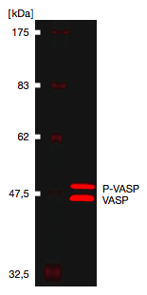

Figure 7: Transgenic expression and phosphorylation
of the human PKA substrate VASP in T. brucei.

Calculation of in vivo PKA activity:
Relative PKA activity in % = (P-VASP/(P-VASP + VASP)) × 100

The trypanosome cultures were treated with toyocamycin, a nucleoside derivative recently identified as potent activator of T. brucei PKA (Bachmaier et al., 2019). Solvent control (1% DMSO) and negative control (untreated trypanosomes) were included in the experiment.

VASP assay protocol
The in vivo kinase reporter assay was performed according to the protocol below:

- trypanosomes were counted and cell density determined

- 1x10⁸ cells were harvested by centrifugation (10 min 1400g 37°C)

- cell pellet was carefully resuspended in 1 ml 37°C HMI9 (avoid harsh pipetting (as this might activate the kinase) and introduction of air bubbles)

- 99 µl cell aliquots were distributed into each of nine prepared 1.5 ml Eppis pre-warmed to 37°C

- incubation 10 min at 37°C (slightly shaking; ~500-600 rpm)

- 1 µl 500 µM toyocamycin or 1 µl DMSO (or no addition = negative control) were added and mixed well but gently (!)

- incubation 10 min at 37°C (slightly shaking)

- meanwhile, Eppendorf tubes filled with 15 µl 6x Laemmli buffer were put into 95°C heating block

- 75 µl cell solution was transferred into Laemmli buffer

- incubation 5 min at 95°C sonication

- run SDS PAGE
  - nine Western blot samples were prepared for each cell line (untreated, DMSO, toyocamycin; three replicates each)
  - one gel for each cell line was loaded according to the following loading scheme:
lane | 1 | 2 | 3 | 4 | 5 | 6 | 7 | 8 | 9 | 10
load | marker | untreated | DMSO | toyo | untreated | DMSO | toyo | untreated | DMSO | toyo

  - 20 µl of each sample & 5 µl of the protein marker (NEB Blue Prestained Protein Standard) were loaded
  - gels were run for ~1.5-2 hours at 20 mA per gel (in order to get good separation of the two VASP bands, the 46 kDa marker band should be very close to the bottom of the gel)

- Western blot
  - proteins were transferred to a PVDF membrane by Western blotting (see ‘common protocols’, p.23)
  - membranes were blocked in 5 ml 5% milk in PBS for 1h at RT
  - incubation with anti-VASP antibody (diluted 1:5000 in 5 ml 1% milk/0.1% PBST) overnight at 4°C on a roller
  - membranes were washed 4x 5 min with 0.2% PBST
  - incubation for 30-60 min at RT with secondary antibody (IRDye680LT goat anti-rabbit; diluted 1:2500 in 5 ml 1% milk/0.1% PBST, 10 µl 10% SDS solution) covered with aluminum foil
  - membranes were washed 4x 5 min with 0.2% PBST, final wash with water
  - membranes were dried between Whatman filter papers (7x10 cm) & scanned with Odyssey Infrared Scanning System and software

analysis:
- import the VASP assay zip file into ImageStudioLite and quantify all bands; export the values as Excel file
- open the Excel file and determine relative PKA activity (percentage of VASP phosphorylation) in the different cell lines and conditions; calculate mean ± SD of the three replicates
- visualize as bar chart in GraphPad Prism and export PDF for your practical course protocol
- calculate the fold change of VASP phosphorylation upon treatment with toyocamycin compared to untreated and DMSO
- enter values in Table 1 (Phenotypic in vivo analysis of T. brucei PKAR mutants)

Cell viability assay (Alamar blue assay)

What you will learn from this experiment:
- How can you determine the viability of cells?
- How can you set-up a cell viability assay suitable for high-throughput drug screening?
- What are the differences in sensitivity to toyocamycin between wildytpe T. brucei and the different PKAR mutants?
- Does toyocamycin kill trypanosomes by binding to PKAR?
- Does trypan blue kill trypanosomes via PKAR?

The Alamar blue cell viability assay provides a homogeneous, fluorometric method for estimating the number of viable cells present in multiwell plates. It uses the indicator dye resazurin to measure the metabolic capacity of cells. Viable cells retain the ability to reduce resazurin into resorufin, which is highly fluorescent (Figure 8). Non-viable cells rapidly lose metabolic capacity, do not reduce the indicator dye and thus do not generate a fluorescent signal.

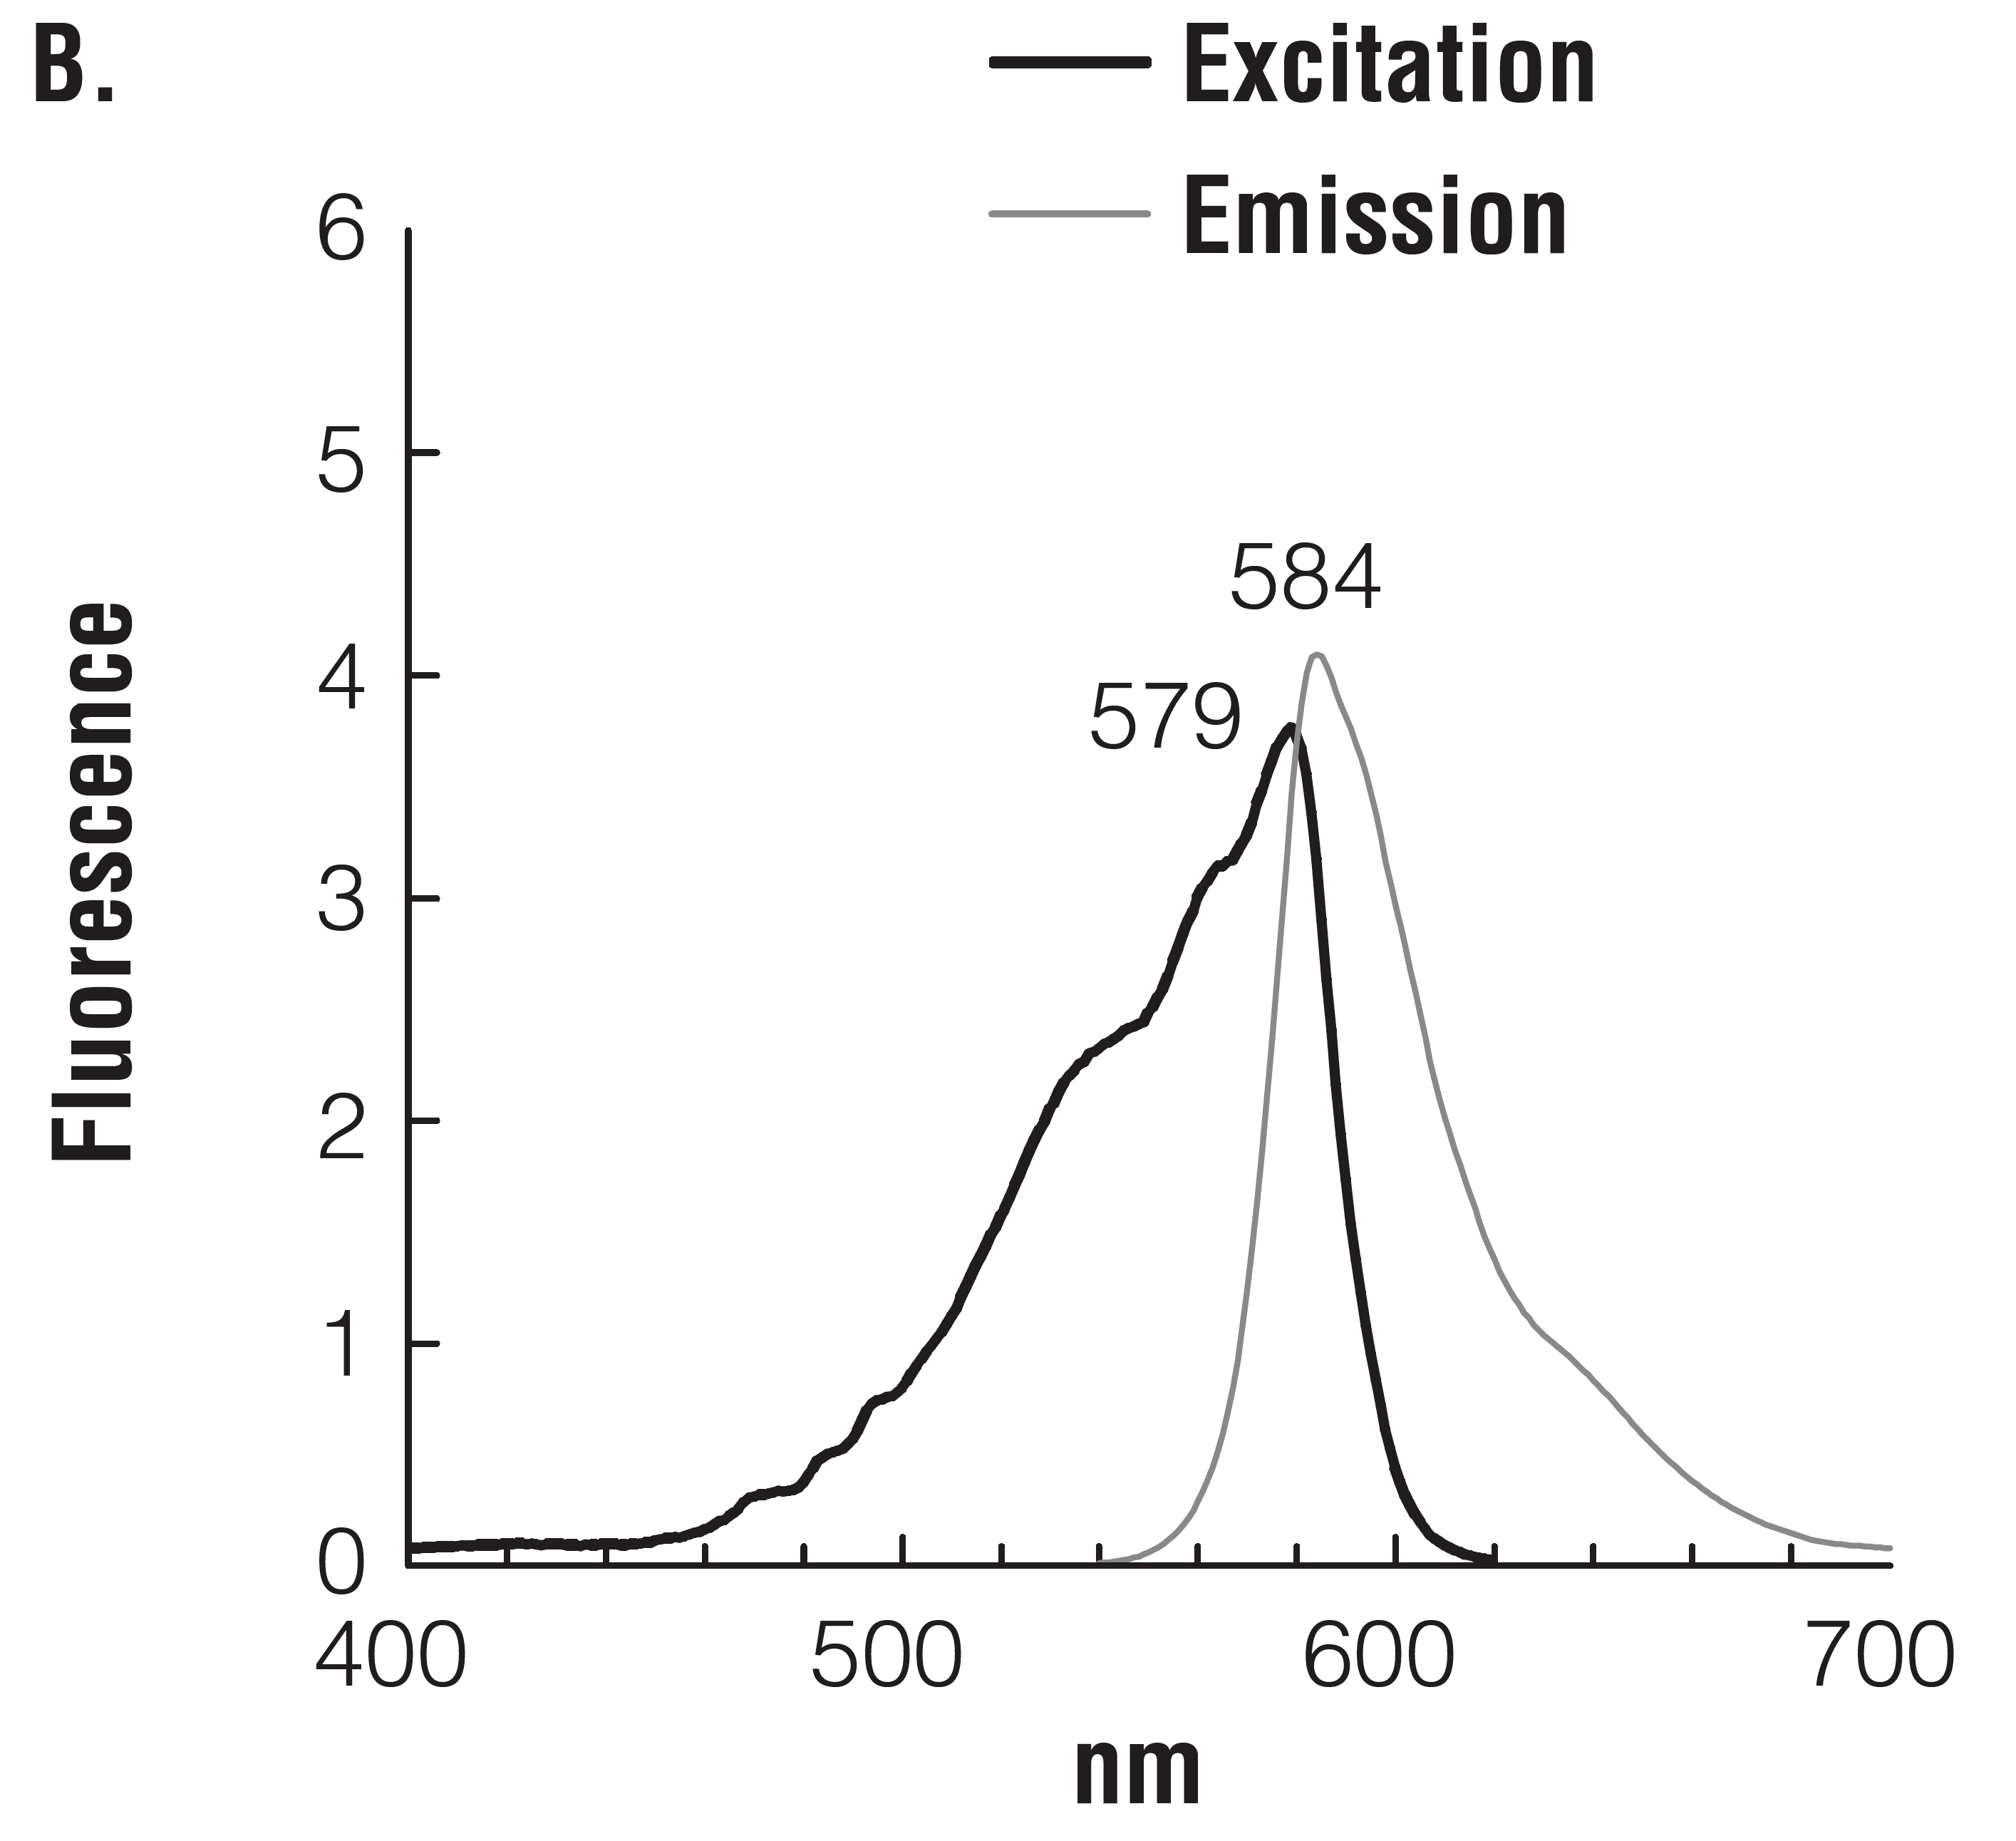
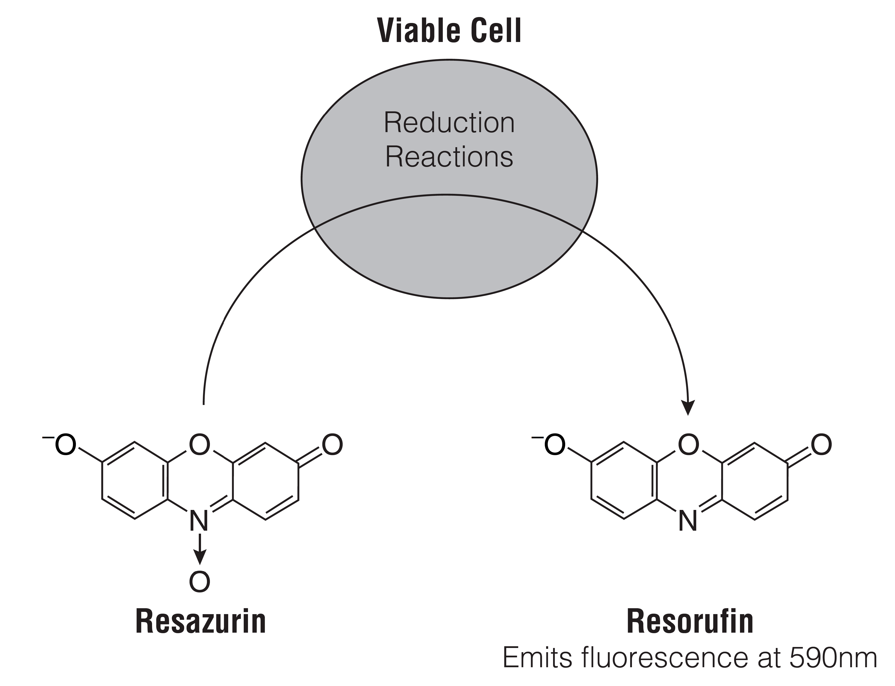
A.
Figure 8. (A) Reduction of resazurin to resorufin. (B) Excitation and emission spectrum of resorufin.

We have used the Alamar blue cell viability assay in order to determine the sensitivity of our different T. brucei cell lines (wild type and PKAR mutants) to toyocamycin (reminder: toyocamycin = nucleoside derivative, activates T. brucei PKA via binding to PKAR). The read out of this assay will provide EC₅₀ (EC: effective concentration) values for toyocamycin for each of the different cell lines. The EC₅₀ value corresponds to the compound concentration that kills 50% of the trypanosomal culture within the time frame of the assay. The viability of untreated cells needs to be analyzed for each cell line and serves as 100% survival control.

In addition, we will compare the sensitivity of wildtype and PKAR knock out trypanosomes for trypan blue (precursor of Suramin, a drug used against 1st stage HAT caused by T. brucei rhodesiense).

Alamar blue assay protocol:
The Alamar blue cell viability assay was performed according to the protocol below:

General remarks:
- Figure 9 shows the set up and pipetting scheme of the 96-well plates
- the assay requires highly accurate pipetting!
- For each cell line, two 96-well plates were used; a serial (2-fold) dilution of toyocamycin was set up from left to right over two 96-well plates (see Fig. 9) in order to cover a large concentration range
- multichannel pipettes were used for most of the steps (except for pipetting the 50 µM toyocamycin stock solution in HMI9; wells colored in blue in Figure 9)
- three rows per cell line were needed for setting up technical triplicates
- a fourth row (compound dilution series as above but without cells = no cells control), was required for background subtraction (background could result from HMI9 medium, autofluorescence of compound etc.)

Assay set-up (practical course 2019)
- prepared once for the whole course:
pipet into a 15 ml Falcon tube: 4950 µl HMI9 + 50 µl 5 mM toyocamycin
distribute into 5 aliquots à 900 µl and distribute one aliquot for each cell line
this is the 50 µM toyocamycin stock solution in HMI9

- done by everyone: fill two 96-well plates according to the instructions shown in Figure 9A and 9B
pipet 200 µl of the 50 µM toyocamycin stock solution in HMI9 into each well colored in blue in Fig. 9A
fill all wells colored in green in Fig. 9 with 100 µl HMI9
use multichannel pipettes to perform serial dilutions of toyocamycin by pipetting 100 µl of the second column (columns are vertical!) of the plate shown in Fig. 9A (wells shown in blue) into the third, gently pipette up and down four times (without air bubbles!) and transfer 100 µl of the third column into the fourth and so on; the serial dilutions will be extended over two plates, i.e. when you are finished with plate 9A, do not discard the solution in the pipet tips but go on with plate 9B; stop before column 11 of plate 9B, since these wells are the ‘no drug controls’!!
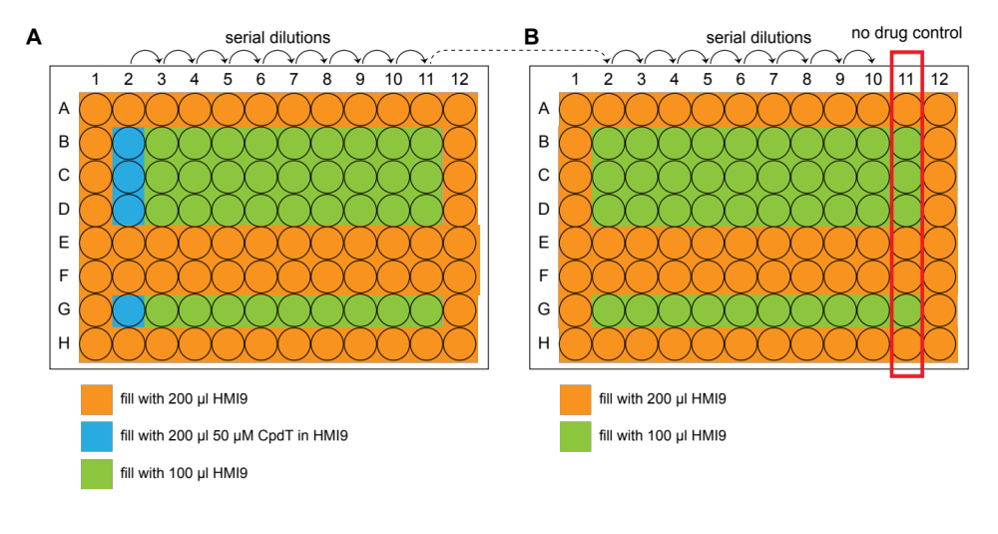
Figure 9. 96 well plate pipetting schemes for Alamar blue assay.

- count cells and calculate cell densities
- determine the culture volume required to get a final concentration of 1x10⁴ cells/ml in a volume of 20 ml
- dilute cells in 20 ml HMI9 in 50 ml Falcon tube and pour the total volume into a reservoir
- use a multichannel pipette to add 100 µl of cells into all wells of rows B, C, D (see Figure 9A and 9B) (you don’t have to change tips if you start from the lowest drug concentration, i.e. from right to left)

- add 100 µl HMI9 to wells of rows G
- fill all wells colored in orange in Fig. 9 with 200 µl HMI9 (empty wells are filled to avoid evaporation)

- seal plates with parafilm and incubate at 37°C for 72 h

Assay read-out:
- add 20 µl of Alamar blue solution (resazurin) into each well using a multipette and incubate for 4 h at 37°C
- Figure 10 shows an example of an Alamar blue assay ready for fluorescence read-out
- measure fluorescence with the fluorescence spectrometer set at λ_{excitation} 538 nm and λ_{emission} 590 nm; software: i-control

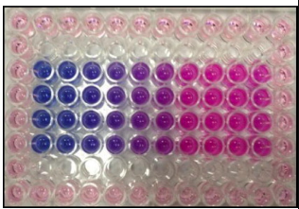
Figure 10. Example of Alamar blue assay ready for fluorescence read-out.

Analysis:
- analyze the data from the Drug Target course 2019 using the Excel workbook “Alamar blue” (provided at the course webpage)
- transfer the data into GraphPad Prism and determine the EC₅₀ values for all cell lines treated with toyocamycin or trypan blue
- export PDFs of the graphs for your protocol
- enter the EC₅₀ values in Table 1 (Phenotypic in vivo analysis of T. brucei PKAR mutants) and compare the results for all cell lines
- do the results match your expectations?

Common protocols

Counting trypanosomes with a Neubauer counting chamber

(modified from http://www.microbehunter.com/2010/06/27/the-hemocytometer-counting-chamber/)

Purpose of the hemocytometer:
The hemocytometer (or haemocytometer or counting chamber) is a specimen slide, which is used to determine the concentration of cells in a liquid sample. It is frequently used to determine the concentration of blood cells (hence the name “hemåo-”) but also the concentration of sperm cells in a sample (or Trypanosoma brucei in our case). The cover glass, which is placed on the sample, does not simply float on the liquid, but is held in place at a specified height (usually 0.1mm). Additionally, a grid is etched into the glass of the hemocytometer. This grid, an arrangement of squares of different sizes, allows for an easy counting of cells. This way it is possible to determine the number of cells in a specified volume.
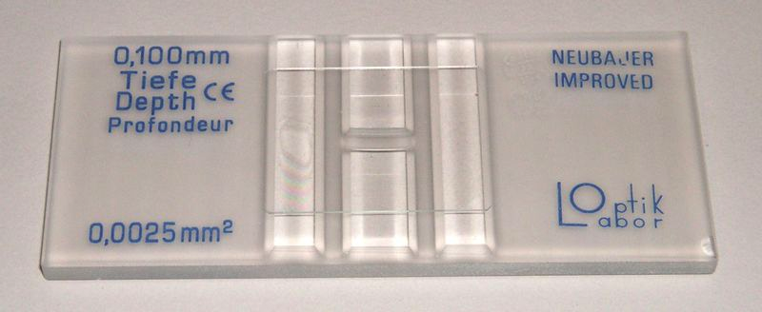

Neubauer Counting chamber

Preparing the sample:
The fluid containing the cells must be appropriately prepared before applying it to the hemocytometer.
- Proper mixing: The fluid should be a homogenous suspension. Cells that stick together in clumps are difficult to count and they are not evenly distributed.
- Appropriate concentration: The concentration of the cells should neither be too high or too low. If the concentration is too high, then the cells overlap and are difficult to count. A low concentration of only a few cells per square results in a higher statistical error and it is then necessary to count more squares (which takes time). Suspensions that have a too high concentration should be diluted 1:10, 1:100 and 1:1000.
- Clean counting chamber and cover slip: clean the Neubauer chamber and the cover slip with 80% ethanol before use
- Fill the counting chamber with cell solution: pipet 10 µl of cell solution to the border of the cover slip; the chamber allows filling with two cultures, as it is split in the middle
1
21

Counting the cells:
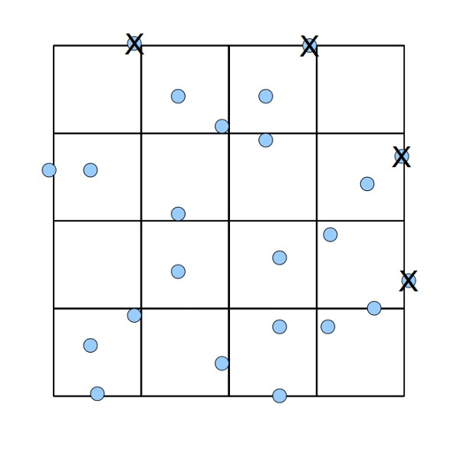
- count moving cells within the light grey big squares (consisting of 16 small squares each), which are marked by red arrows in the picture below (left)
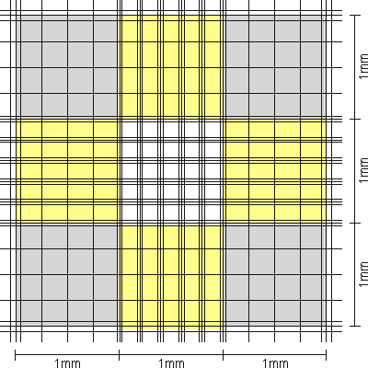
- Counting cells that are on a line (picture above, right): Cells that are on the line of a grid require special attention. Cells that touch the top and right lines of a square should not be counted, cells on the bottom and left side should be counted.
Calculating the cell density: Here it is necessary to do some simple math. The following numbers are needed: number of cells counted in the four big squares, area of the squares (1 mm²), height of the sample (0.1 mm), dilution factor. The objective is to find the number of cells in 1ml of original solution.

Assembly of Western blots

- for each Western blot we need 6 Whatman papers; four will be soaked in anode buffer and two in cathode buffer
- activate membrane in methanol for ≥5 seconds and subsequently wash with water (from both sides) to remove the methanol
- assemble the blot (see figure below):
cover 4 Whatman papers wetted in anode buffer with the activated membrane
add the protein gel without trapping air bubbles between membrane and gel
cover with 2 Whatman papers wetted in cathode buffer
remove air bubbles
- transfer proteins from gel to membrane with a current density of 1 mA/cm² for 1 hour

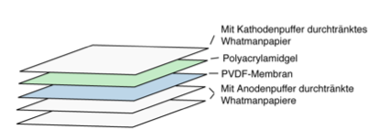

Assembly of a Western blot

